**[Add One Row to Tree](https://leetcode.com/problems/add-one-row-to-tree/)**

Given the root of a binary tree and two integers val and depth, add a row of nodes with value val at the given depth depth.

Note that the root node is at depth 1.

The adding rule is:

* Given the integer depth, for each not null tree node cur at the depth depth - 1, create two tree nodes with value val as cur's left subtree root and right subtree root.
* cur's original left subtree should be the left subtree of the new left subtree root.
* cur's original right subtree should be the right subtree of the new right subtree root.
* If depth == 1 that means there is no depth depth - 1 at all, then create a tree node with value val as the new root of the whole original tree, and the original tree is the new root's left subtree.

**Example 1:**

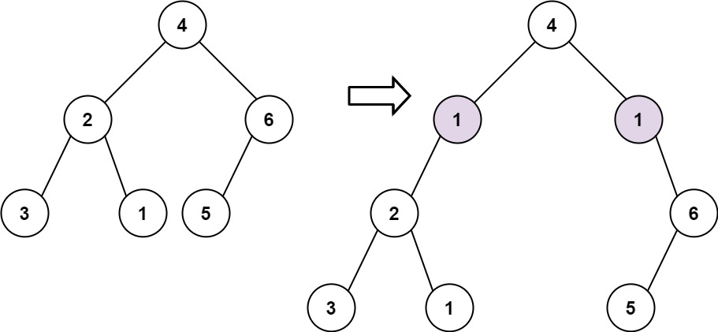

**Input:** root = [4,2,6,3,1,5], val = 1, depth = 2

**Output:** [4,1,1,2,null,null,6,3,1,5]

**Example 2:**

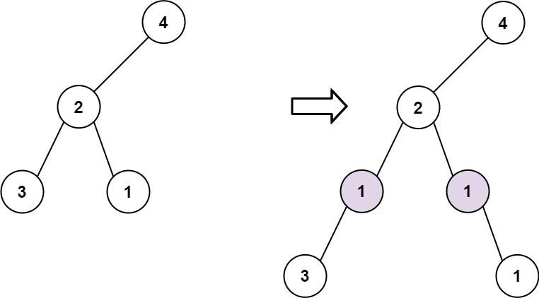

**Input:** root = [4,2,null,3,1], val = 1, depth = 3

**Output:** [4,2,null,1,1,3,null,null,1]

**Constraints:**

* The number of nodes in the tree is in the range [1, 104].
* The depth of the tree is in the range [1, 104].
* -100 <= Node.val <= 100
* -105 <= val <= 105
* 1 <= depth <= the depth of tree + 1

Code : class Solution {

public:

    TreeNode* add(TreeNode* root, int val, int depth, int curr) {

        if (!root)

            return nullptr;

        if (curr == depth - 1) {

            TreeNode* lTemp = root->left;

            TreeNode* rTemp = root->right;

            root->left = new TreeNode(val);

            root->right = new TreeNode(val);

            root->left->left = lTemp;

            root->right->right = rTemp;

            return root;

        }

        root->left = add(root->left, val, depth, curr + 1);

        root->right = add(root->right, val, depth, curr + 1);

        return root;

    }

    TreeNode* addOneRow(TreeNode* root, int val, int depth) {

        if (depth == 1) {

            TreeNode* newRoot = new TreeNode(val);

            newRoot->left = root;

            return newRoot;

        }

        return add(root, val, depth, 1);

    }

};

Link : <https://leetcode.com/problems/add-one-row-to-tree/?envType=daily-question&envId=2024-04-16>